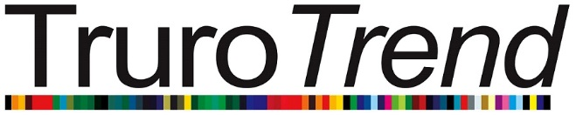


Truro Trend 2018 – Invitation to be involved

Dear Truro businesses,
We are writing to all fashion retailers, hair and beauty businesses in the city centre to invite you to join in with the city’s annual fashion week – Truro Trend.
The event will be returning to our high street from 1 - 7 October 2018.
The event is organised and funded by Truro BID and highlights the diverse range of quality businesses on the high-street of this great little city through in-store events and the return of the high-profile catwalk show at Truro Cathedral on the evening of Wednesday 3rd October.
The aim of Truro Trend Fashion Week is to promote the unique retail offer within Truro. This is clear in the enviable range of independent stores and high street labels open in all corners of the city. In a compact city centre, this strong and diverse mix is unique - Truro is a special place and we want to celebrate it!
A targeted marketing campaign will once again be in place to promote all the activities and businesses involved with Truro Trend this year. This will include a marketing support pack for every business and extensive PR reach in print and radio. We will also be continuing with a dedicated Facebook campaign and creating a new Instagram account to support the activities, so we would really appreciate you ‘liking’ and ‘sharing’ @TruroTrend as much as possible.
We are particularly keen to increase the instore events this year. Many businesses partnered to add extra special events for customers in previous years, and it would be wonderful to see more of this. So, if you are keen to collaborate – let us know and we will put you in touch with other businesses in the city centre that are keen to do the same.

If you are interested in being a part of the Truro Trend Fashion Week in 2018, please email us with your choice of the following elements you would like to be included in (you can select as many as you like):

- Host an event in your store during the week.
You will be provided with a Truro Trend promotional pack to help support your event.

- Take part in the catwalk element of the fashion show.
Spaces are limited for this, so please let me know asap.

- Contribute Hair and Make-up skills to the catwalk element of the fashion show.
Again, we are limited to the number of businesses involved in this element also, so please let me know asap.

- Have a trade stand at the Fashion Show.
There will be a fee of £25 (+vat) to have a stand, this is to cover infrastructure costs.

- Put a poster promoting the week in your shop window
These will be distributed at the beginning of September

Please email your answers to: alun.jones@trurobid.co.uk
Deadline for inclusion in this event is Friday 30th June. Please note we do not need to have details of your in-store event by this date, just your commitment to the event.
We look forward to your reply.
Kind regards,
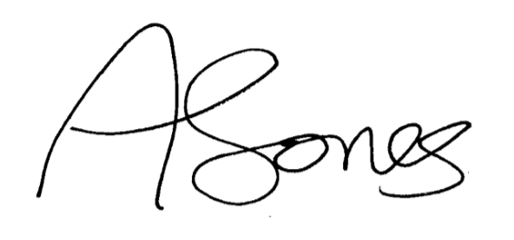

Alun Jones
BID Manager
Truro BID
alun.jones@trurobid.co.uk
Tel: 01872 273999

