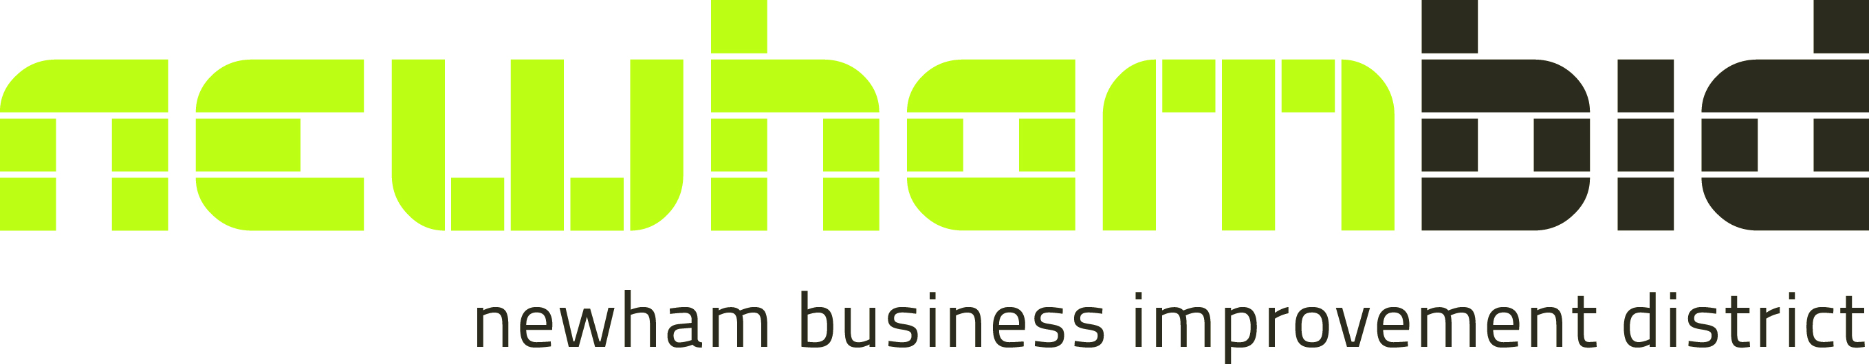

Notice of Annual General Meeting
Notice is hereby given that the Annual General Meeting of the Totally Truro Company (incorporating Truro BID and Newham BID) will be held virtually via zoom:
Tuesday 10th November 2020 at 11.00am for the following purposes:

1. To approve the minutes of the AGM held on 12th November 2019

2. To receive the report of the Directors and the accounts for the year ending 31st March 2020 and approve the accounts

2. To elect new Directors for whom nominations have been received – no new nominations received

3. To reappoint Directors whose term has ended but who are happy to re-stand

3. BID presentation for Truro BID and Newham BID

4. Q&A session

By order of the Board

Carole Theobald Chairman Kristian Fleming, Chairman
Newham BID Truro BID

Registered address: First Floor, Union Place, Truro, TR1 1EP
Company Number: 06070111

Notes:

1. Appointment of Proxies:

a) If you are a member who is entitled to attend and vote at the meeting, you are entitled to appoint one or more proxies to exercise all or any of your rights to attend, speak and vote at the meeting and you should have received a proxy form with this notice of meeting. A proxy does not need to be a member of the Company but must attend the meeting to represent you. You can only appoint a proxy using the procedures set out in these notes and the notes to the proxy form.

b) You may appoint the Chairperson to vote on your behalf in which case your wishes can be recorded on the proxy form
c) If you do not give your proxy an indication of how to vote on any resolution, your proxy will vote or abstain from voting at his or her discretion. Your proxy will vote (or abstain from voting) as he or she thinks fit in relation to any other matter which is put before the Meeting.

BID Directors – Existing

The following people are all current Directors of Totally Truro and are happy to remain in the role:

1. Rolf Munding, Routenote Ltd

2. Mark Roby, Stephens Scown LLP (Solicitors)

BID Directors – Re-Standing

The following people are all current Directors of Totally Truro who have been Directors for three years but are happy to re-stand

3. Nick Seaton Burridge, Managing Director, Belmont Property Management

4. Simon Hendra, Director, G J Hendra Ltd

5. Carole Theobald, Deputy Chief Executive and Director of Operations, iSight Cornwall (Chair of Newham BID)

6. Kristian Fleming, Inhabit (Chair of Truro BID)

BID Directors – Retiring

The following Directors have retired from the Board:

1. Alison Elvey, Grants Specialist, Robinson Reed Layton

BID Directors - New Nominations

There are no new nominations for Director positions

Notes:
In appointing Directors, the Board seeks a broad spectrum of skills, qualities and experience to ensure that the many and varied interests of BID members are reflected and represented contributing towards the success of the Company. The Board also seeks a balance of Directors drawn from both Truro BID Committee and Newham BID Committee that steer the delivery of the respective business plans.

Nominations for new Directors are always welcome and these Directors would already have a place on the respective BID Committee and if their appointment is ratified, they would have a place on the Totally Truro Board. If you are interested in being a member of either Truro or Newham BID Committee and/or becoming a Director of Totally Truro, please contact either Alun Jones (alun.jones@trurobid.co.uk) or Mel Richardson (mel@newhambid.co.uk)

16th October 2020

